Cairo University Faculty of Computers and Information



**Software Engineering II**

**Software design specification document**

**2020**

**Project Team**

|  |  |  |  |
| --- | --- | --- | --- |
| **ID** | **Name** | **Email** | **Mobile** |
|  | Ahmed Sayed | [Ahmed111522@gmail.com](mailto:Ahmed111522@gmail.com) | 01100261796 |
|  | Ashraf Samir | [Ashrafsamer423@gmail.com](mailto:Ashrafsamer423@gmail.com) | 01200977469 |
|  | Hatem Sayed | [Hatemgad98@gmail.com](mailto:Hatemgad98@gmail.com) | 01000275167 |
|  |  |  |  |
|  |  |  |  |
|  |  |  |  |

**[Mahmoud haddad]**

Contents

Class diagram design 2

Sequence diagram design 3

Github repository link 5

# Class diagram design

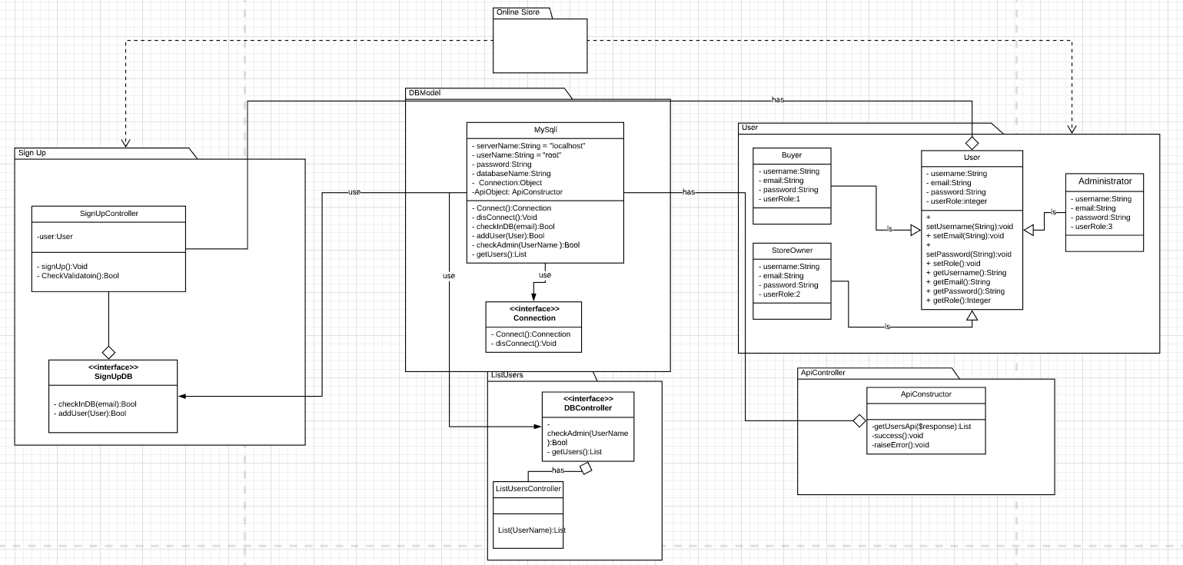

# Sequence diagram design

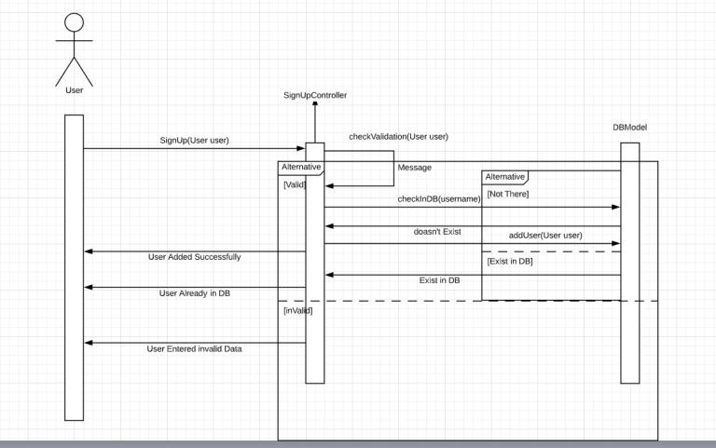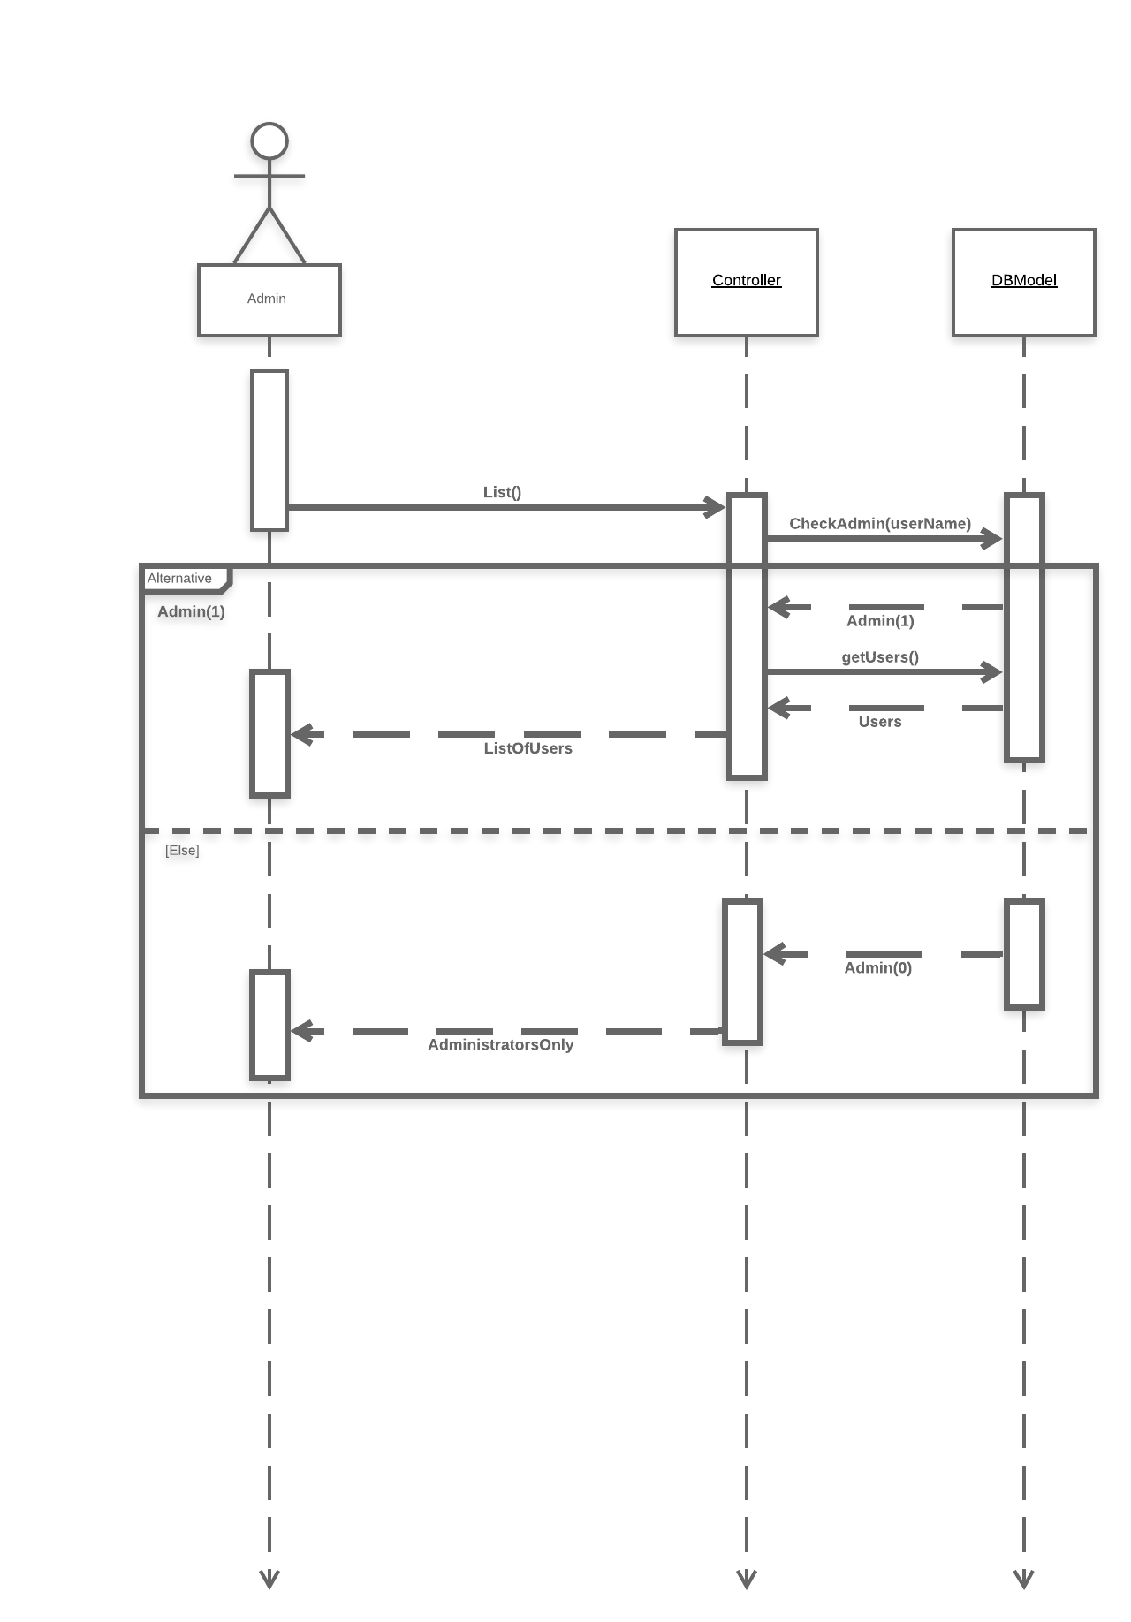

# Github repository link

* <https://github.com/AshrafSamir/SoftwareProjectOnlineStore>,